Social Media — Task Sheet
Instructions: Do not change the question text. Write your answer directly below each question. For Objective questions, the expected output columns and row counts are given below the question. For Subjective questions, no such details are given, work out and write the answer on your own.

Objective Questions
Q1 Are there any tables with duplicate or missing null values? If so, how would you handle them?

ANSWER:

I checked the tables for duplicate records and NULL values using COUNT(*) - COUNT(DISTINCT id) to identify duplicates and SUM(column IS NULL) to count missing values. After examining the tables, I found that none of them contain duplicate records or NULL values. This helps maintain data accuracy and reliability for further analysis.

CODE:
SELECT 'users', COUNT(*) - COUNT(DISTINCT id) AS Duplicates, SUM(username IS NULL) AS NullValues FROM users

UNION ALL

SELECT 'photos', COUNT(*) - COUNT(DISTINCT id), SUM(image_url IS NULL) FROM photos

UNION ALL

SELECT 'comments', COUNT(*) - COUNT(DISTINCT id), SUM(comment_text IS NULL) FROM comments

UNION ALL

SELECT 'likes', COUNT(*) - COUNT(DISTINCT user_id, photo_id), 0 FROM likes

UNION ALL

SELECT 'follows', COUNT(*) - COUNT(DISTINCT follower_id, followee_id), 0 FROM follows

UNION ALL

SELECT 'photo_tags', COUNT(*) - COUNT(DISTINCT photo_id, tag_id), 0 FROM photo_tags

UNION ALL

SELECT 'tags', COUNT(*) - COUNT(DISTINCT id), SUM(id IS NULL) FROM tags;

OUTPUT IMAGE:

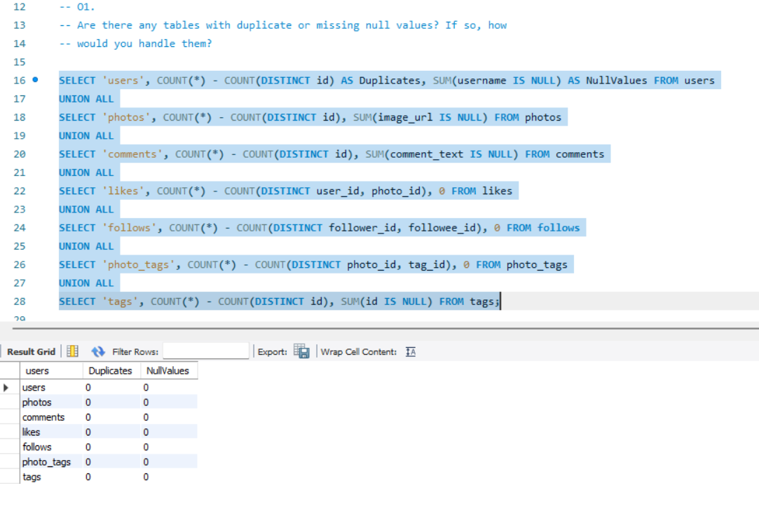

Q2 What is the distribution of user activity levels (e.g., number of posts, likes, comments) across the user base?

ANSWER:

a. Photos_posted: This column represents the no. of posts/photo_posted by each user. The number of photos posted shows how frequently a user contributed content, reflecting their overall activity level.
b. Tags_used: This column represents the distinct count of tags used by each user. The distinct count of tags indicates how actively a user is engaging with different topics or communities, suggesting a broader involvement in the platform.
c. Comments_made: This column represents the comments made by each user. Comments demonstrate not just passive consumption but active participation in discussions, showing a user's willingness to engage with others.
d. Likes_done: This column represents the no. of photos liked by each user. The number of likes given reflects a user's engagement with others' content, indicating how much they interact with the community.

OVERALL ACTIVITY LEVEL:
Together, these parameters provide a well-rounded view of user activity. They capture both content creation and interaction, helping to assess how involved a user is on the platform. A user who actively posts, tags, comments, and likes are likely to have a higher activity level, indicating a vibrant engagement with the community.

CODE:
WITH user_photos AS (
SELECT
user_id,
COUNT(id) AS total_posts
FROM photos
GROUP BY user_id
),
user_tags AS (
SELECT
p.user_id,
COUNT(DISTINCT pt.tag_id) AS total_tags
FROM photos p
INNER JOIN photo_tags pt
ON p.id = pt.photo_id
GROUP BY p.user_id
),
user_comments AS (
SELECT
user_id,
COUNT(id) AS total_comments
FROM comments
GROUP BY user_id
),
user_likes AS (
SELECT
user_id,
COUNT(*) AS total_likes
FROM likes
GROUP BY user_id
)
SELECT
u.id AS user_id,
u.username,
COALESCE(up.total_posts, 0) AS photos_posted,
COALESCE(ut.total_tags, 0) AS tags_used,
COALESCE(uc.total_comments, 0) AS comments_made,
COALESCE(ul.total_likes, 0) AS likes_given
FROM users u
LEFT JOIN user_photos up
ON u.id = up.user_id
LEFT JOIN user_tags ut
ON u.id = ut.user_id
LEFT JOIN user_comments uc
ON u.id = uc.user_id
LEFT JOIN user_likes ul
ON u.id = ul.user_id
ORDER BY u.id;

OUTPUT IMAGE: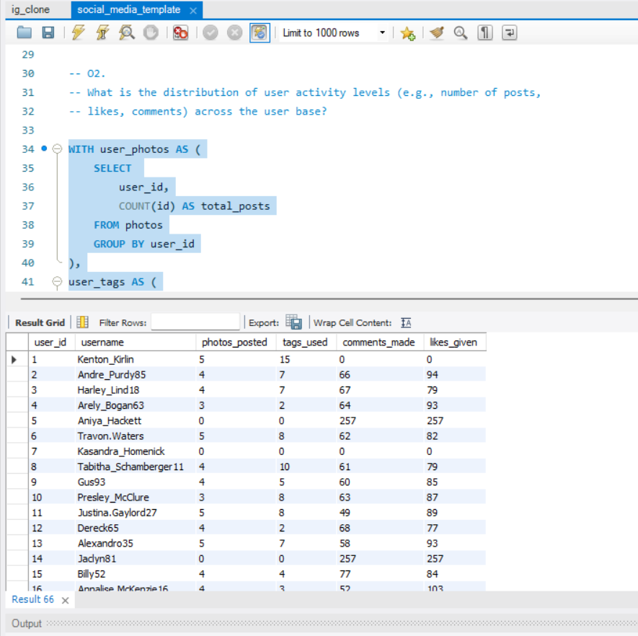
- Count Of Photos Posted By User: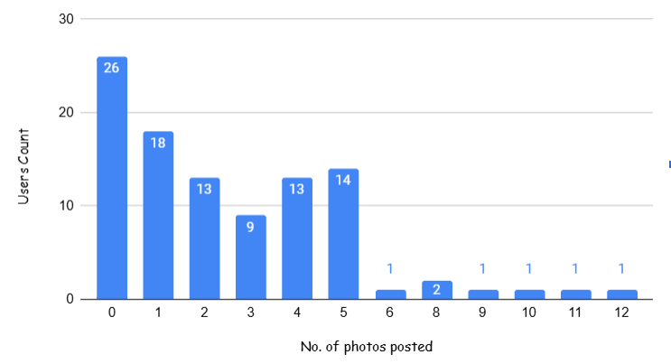
OBSERVATION:
High Inactivity: 26% of users haven’t posted any photos, highlighting a large inactive segment that presents a significant engagement opportunity.
Low Posting Activity: 44% of users have posted between 1 to 3 photos, indicating low to moderate activity, where targeted campaigns could boost participation.
Moderate Posting Activity: 40% of users have posted 4-5 photos, showing they are moderately engaged and could be motivated to post more with the right incentives.
High Posting Activity: Only 7% of users have posted more than 5 photos, representing super-engagers who could be rewarded to maintain or increase their activity.

- User Count By Comments Made
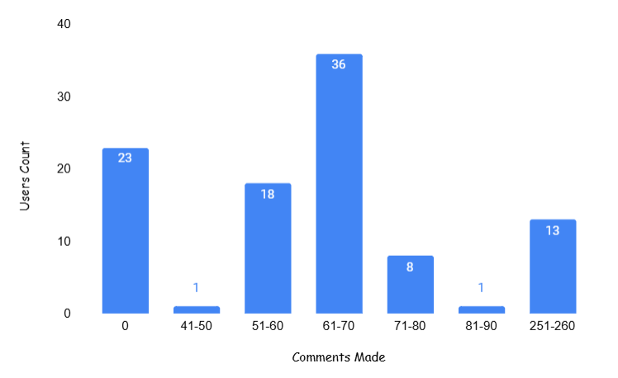
OBSERVATION:

A significant number of users (23) have not made any comments, indicating a potential area for improvement in user engagement.
The range of 51-60 comments has a count of 18, showing that while there is some activity, it is still below what might be expected for a highly engaged user base.
Many users (36) fall within the 61-70 comments range, suggesting that this group is moderately engaged and could be targeted for initiatives to increase their activity levels.
There are few users (9) in the higher ranges (71-80 and 81-90), indicating that very few users are actively participating in discussions or engaging with content at a high level.
The category of 251+ comments have 13 users, indicating a small but dedicated group of super-engagers who actively participate in discussions and such HIGH ACTIVITY makes it suspicious to have called them as ‘BOT USERS’

- Users Count By Likes Done
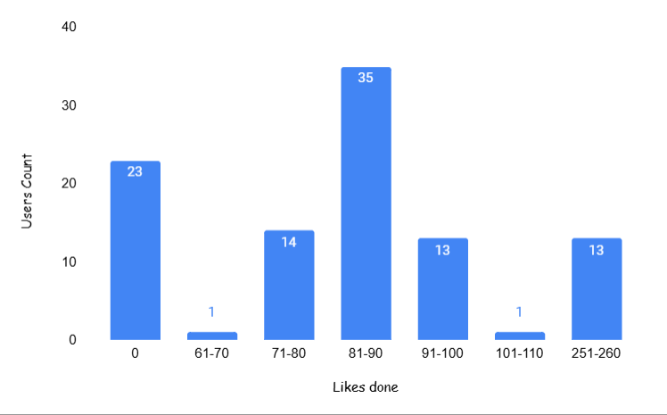

OBSERVATION:
A notable number of users (23) have not given any likes, suggesting a significant segment of the user base is disengaged and may need targeted strategies to encourage interaction with content.
The range of 81-90 likes has the highest count (35 users), indicating a moderately engaged group that actively interacts with posts. This segment presents an opportunity for initiatives aimed at further increasing their participation.
The 71-80 likes category has 14 users, showing some level of interaction, while the 91-100 range includes 13 users, indicating a drop in engagement as users move into higher liking frequencies.
The category of 251-260 likes includes 13 users, indicating a dedicated group of super-engagers who frequently interact with content. These users can be pivotal in community-building efforts and may be influential in encouraging others to engage.

- Users Count By Tags Used
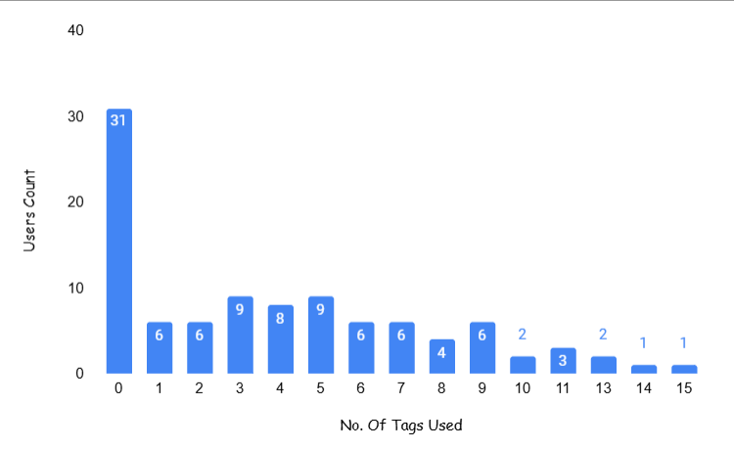

OBSERVATION:

A significant portion of users (31) have not used any tags, indicating that a large segment of the user base is either unaware of the tagging feature or does not see its value in enhancing their posts' reach.
Many users (6-9 users) fall within the range of using 1 to 7 tags. This suggests that most users are experimenting with tags but are not using them extensively, presenting an opportunity to educate users on the benefits of using more tags for discoverability.
Users using 3 to 9 tags are consistent in number, with 4-9 users in each range, suggesting a small but consistent pattern of tag usage across this group.
There are very few users (2-3) in the higher tag ranges (10-15), indicating that only a small number of users are actively utilizing many tags per post.

Q3 Calculate the average number of tags per post (photo_tags and photos tables).

ANSWER:

Used a subquery to first calculate the tag count per photo, then average those counts.

CODE:
SELECT
ROUND(AVG(tag_count), 2) as avg_tags_per_post
FROM (SELECT
p.id,
COUNT(pt.tag_id) as tag_count
FROM photos p
LEFT JOIN photo_tags pt ON p.id = pt.photo_id
GROUP BY p.id
) as post_tags;

OUTPUT:
avg_tags_per_post = 1.95

Q4 Identify the top users with the highest engagement rates (likes, comments) on their posts and rank them.

ANSWER:

To identify users with the highest engagement:
- Calculated the total number of likes and comments received per post for each user.
- Summed engagement across all their posts.
- Applied DENSE_RANK() to rank users from highest to lowest engagement.
This helps discover which users generate the most interaction on their content.

CODE:
WITH engagement AS (
SELECT
u.id,
u.username,
p.id AS photo_id,
COUNT(DISTINCT l.user_id) AS likes,
COUNT(DISTINCT c.user_id) AS comments
FROM users u
LEFT JOIN photos p ON u.id = p.user_id
JOIN likes l ON l.photo_id = p.id
JOIN comments c ON c.photo_id = p.id
GROUP BY u.id, u.username, p.id
)
SELECT
id,
username,
SUM(likes + comments) AS total_engagement,
DENSE_RANK() OVER (ORDER BY SUM(likes + comments) DESC) AS engagement_rank
FROM engagement
GROUP BY id, username;

OUTPUT IMAGE:
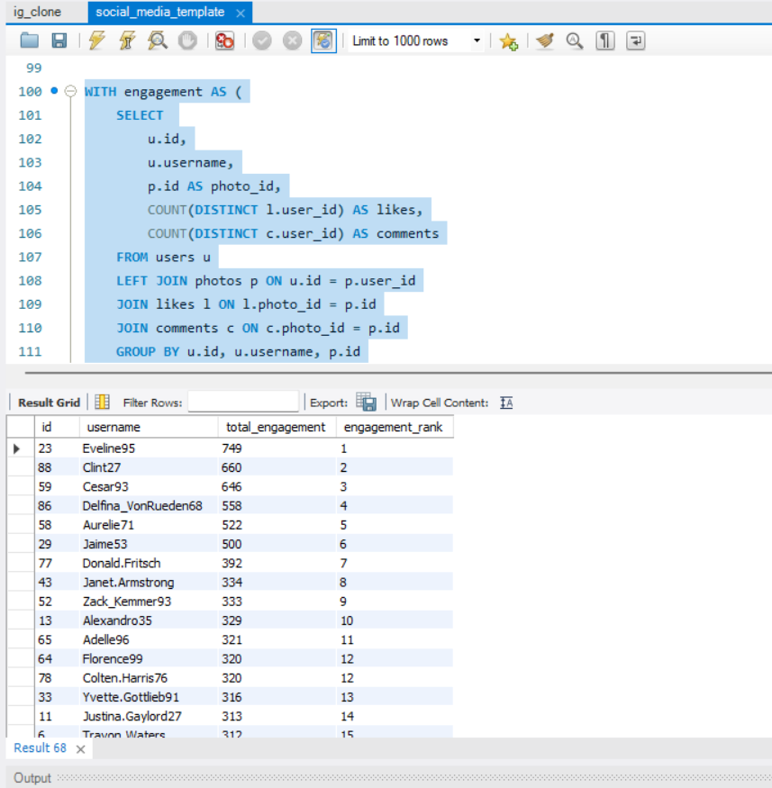

Q5 Which users have the highest number of followers and followings?

ANSWER:

This query identifies the top 5 users with the highest number of followers and the top 5 users who follow the most people. The COUNT(*) function calculates the total followers or followings for each user, while GROUP BY groups the records by user ID. The ORDER BY clause sorts the results in descending order, and LIMIT 5 selects the top five users in each category.
The UNION ALL operator combines both results into a single output, with the category column distinguishing the most-followed users from those who follow the most people. This analysis helps understand user popularity, influence, and networking patterns on the platform.

CODE:
(SELECT
'Most Followed' AS Category,
followee_id AS UserID,
COUNT(*) AS Total
FROM follows
GROUP BY followee_id
ORDER BY Total DESC
LIMIT 5)

UNION ALL

(SELECT
'Most Following' AS Category,
follower_id AS UserID,
COUNT(*) AS Total
FROM follows
GROUP BY follower_id
ORDER BY Total DESC
LIMIT 5);

OUTPUT IMAGE:
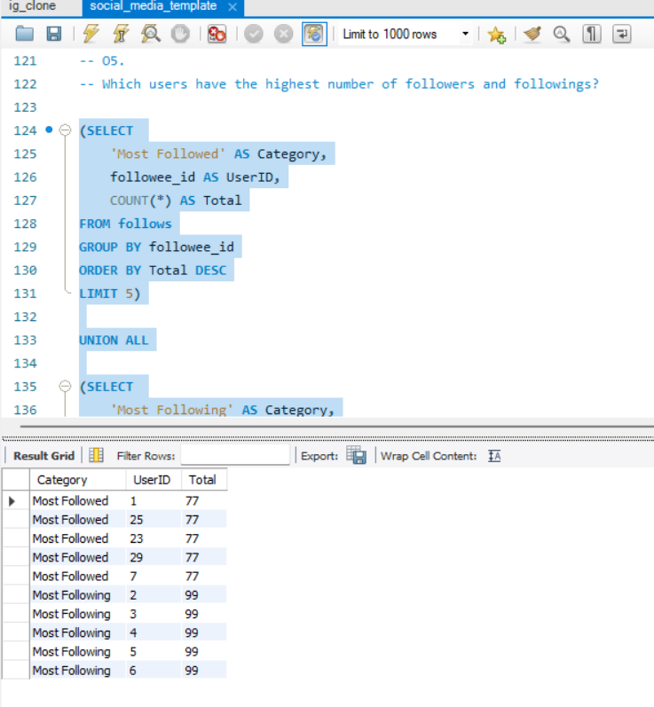

Q6 Calculate the average engagement rate (likes, comments) per post for each user.

ANSWER:
It retrieves the user ID, username, and engagement rate for users who have made at least one post. We used AVG(likes + comments) per post. This shows how well posts are performing on average.
The main purpose is to evaluate content performance.

CODE:
SELECT
u.id,
u.username,
round(AVG(
(SELECT
COUNT(*)
FROM likes l
WHERE l.photo_id = p.id)
+(SELECT
COUNT(*)
FROM comments c
WHERE c.photo_id = p.id)),2) AS AvgEngagementPerPost
FROM users u
LEFT JOIN photos p ON u.id = p.user_id
GROUP BY u.id, u.username
ORDER BY AvgEngagementPerPost DESC;

OUTPUT IMAGE:
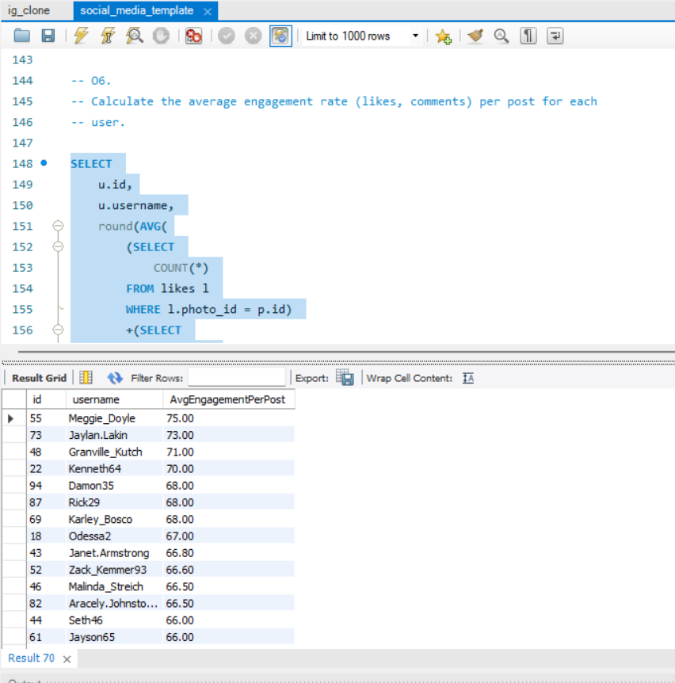

Q7 Get the list of users who have never liked any post (users and likes tables)

ANSWER:
This query retrieves the ID and username of users whose IDs are not present in the likes table. Used LEFT JOIN likes and filtered WHERE l.user_id IS NULL. This is the list of users who haven’t interacted with posts via likes. This identifies inactive users for engagement strategies.
CODE:
SELECT
u.id,
u.username
FROM users u
LEFT JOIN likes l ON u.id = l.user_id
WHERE l.user_id IS NULL;
OUTPUT IMAGE:
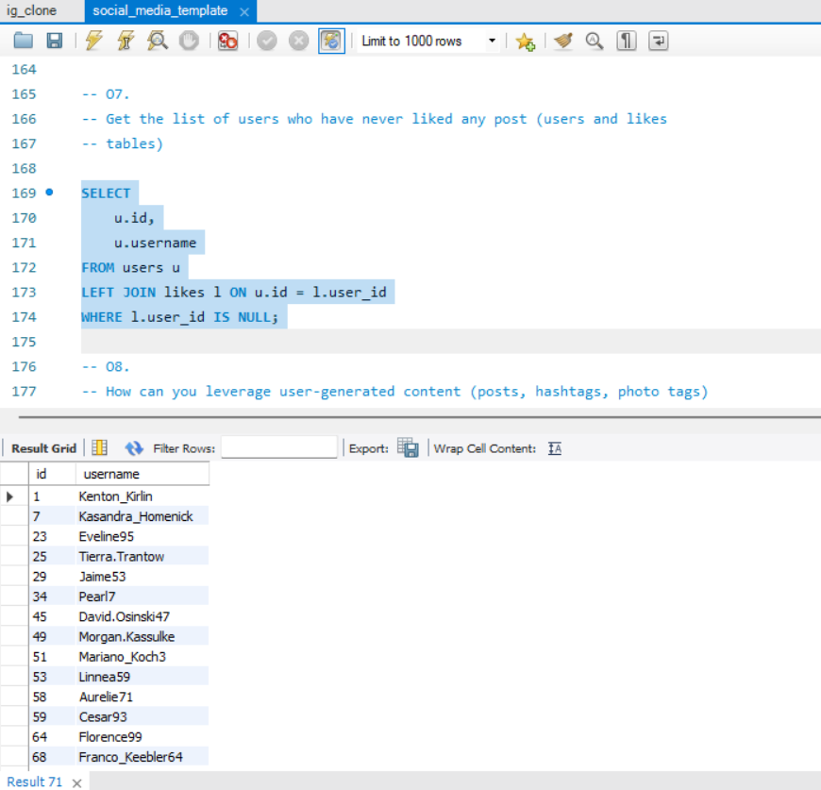

Q8 How can you leverage user-generated content (posts, hashtags, photo tags) to create more personalized and engaging ad campaigns?

ANSWER:
To use user-generated content for personalized ad targeting:
- Analyze which tags (topics or categories) are used most across photos
- Measure:
  - Number of posts per tag
  - Number of unique users using that tag
  - Number of likes received on posts with that tag
- This help identify popular interests, active communities, and high-engagement content themes
CODE:
SELECT
tag_name,
COUNT(pt.photo_id) AS num_posts,
COUNT(DISTINCT p.user_id) AS num_users,
COUNT(l.photo_id) AS num_likes,
(
COUNT(pt.photo_id) +
COUNT(DISTINCT p.user_id) +
COUNT(l.photo_id)
) AS total_engagement_per_tag
FROM photos p
JOIN photo_tags pt ON p.id = pt.photo_id
JOIN tags t ON pt.tag_id = t.id
JOIN likes l ON p.id = l.photo_id
GROUP BY t.id, t.tag_name
ORDER BY num_posts DESC, num_users DESC;

OUTPUT IMAGE:
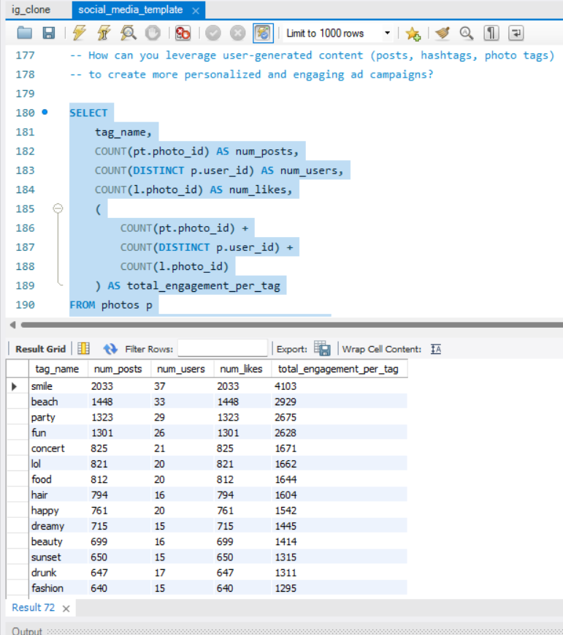

Use results to design interest-based ad segments
Tags like #smile, #beach, #party, and #fun consistently lead in both number of posts and unique user participation. This indicates these topics are not only popular in volume but also widely adopted by the user base, suggesting they resonate broadly. In contrast, tags like #foodie, #delicious, and #photography show moderate to high engagement but are used by fewer users, hinting at niche but dedicated communities. These insights can guide marketers in selecting high-reach hashtags for broad appeal or niche ones for targeted campaigns.
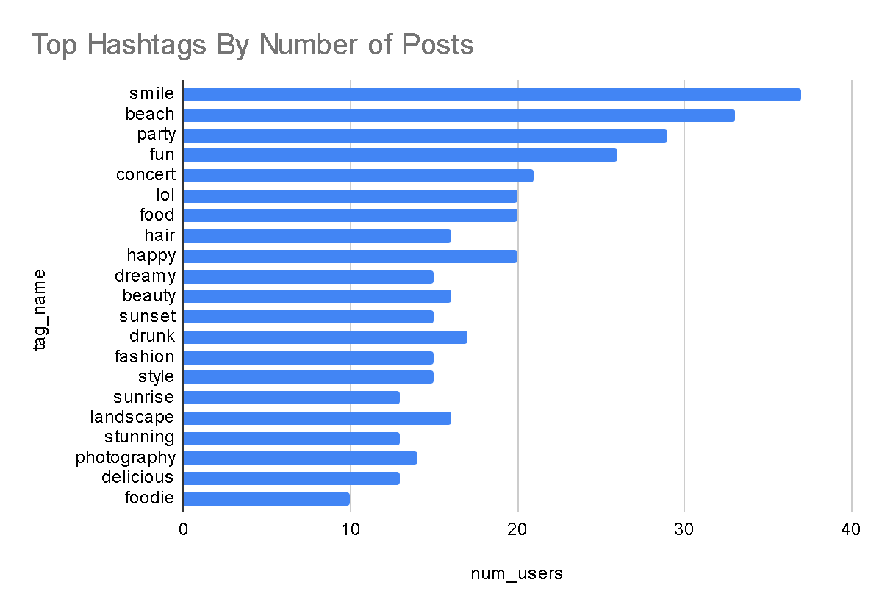

Q9 Are there any correlations between user activity levels and specific content types (e.g., photos, videos, reels)? How can this information guide content creation and curation strategies?

ANSWER:

Here I used a query to collect the number of photos uploaded, total number of likes received on their photos, total number of comments received on their photos. After that I used LEFT JOIN to ensure all users are included, even if they have no uploads, likes or comments. Also I used COALESCE which replaces any NULL values with 0 for users with no activity, then Group By user_id to count uploads, likes and comments per user.

CODE:
WITH photo_counts AS (
SELECT user_id, COUNT(*) AS photo_uploads
FROM photos
GROUP BY user_id
),
engagement_counts AS (

SELECT
p.user_id,
COUNT(l.photo_id) AS total_likes,
COUNT(c.id) AS total_comments
FROM photos p
LEFT JOIN likes l ON p.id = l.photo_id
LEFT JOIN comments c ON p.id = c.photo_id
GROUP BY p.user_id
)
SELECT
u.id AS user_id,
u.username,
COALESCE(pc.photo_uploads, 0) AS photo_uploads,
COALESCE(ec.total_likes, 0) AS total_likes,
COALESCE(ec.total_comments, 0) AS total_comments
FROM users u
LEFT JOIN photo_counts pc ON u.id = pc.user_id
LEFT JOIN engagement_counts ec ON u.id = ec.user_id
ORDER BY u.id;

OUTPUT IMAGE:
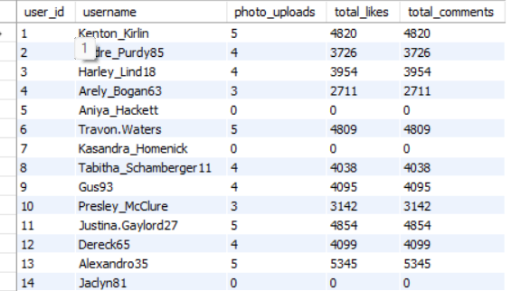
OBSERVATION:

1. User Activity Levels:

Photo Uploads: The number of photos uploaded by users ranges significantly, with some users not uploading any photos at all, while others have uploaded up to 12 photos (e.g., Eveline95).
Total Likes and Comments: These metrics are directly linked to user engagement, with higher counts typically correlating to more uploads and interactions.

2. Engagement Metrics:
Users who upload more photos tend to receive more likes and comments. For instance, Eveline95 uploaded 12 photos and received 420 likes and 329 comments, demonstrating a strong positive correlation between photo uploads and user engagement.
Conversely, users with no uploads often have zero likes and comments (e.g., Aniya_Hackett, Kasandra_Homenick, and others).
CORRELATION BETWEEN UPLOADS AND ENGAGEMENT:

SELECT
photo_uploads,
ROUND(AVG(total_engagement), 0) AS average_engagement
FROM (
SELECT
u.id,

(SELECT COUNT(*) FROM photos p WHERE p.user_id = u.id) AS photo_uploads,

(
SELECT COUNT(*) FROM likes l
WHERE l.photo_id IN (SELECT id FROM photos WHERE user_id = u.id)
) +
(
SELECT COUNT(*) FROM comments c
WHERE c.photo_id IN (SELECT id FROM photos WHERE user_id = u.id)
) AS total_engagement
FROM users u
) user_metrics
WHERE photo_uploads > 0
GROUP BY photo_uploads
ORDER BY photo_uploads;

It calculates the average total engagement (likes + comments) per user, grouped by the number of photo uploads.
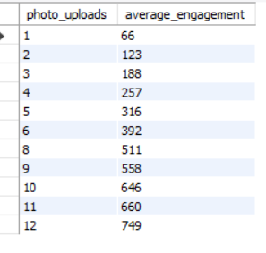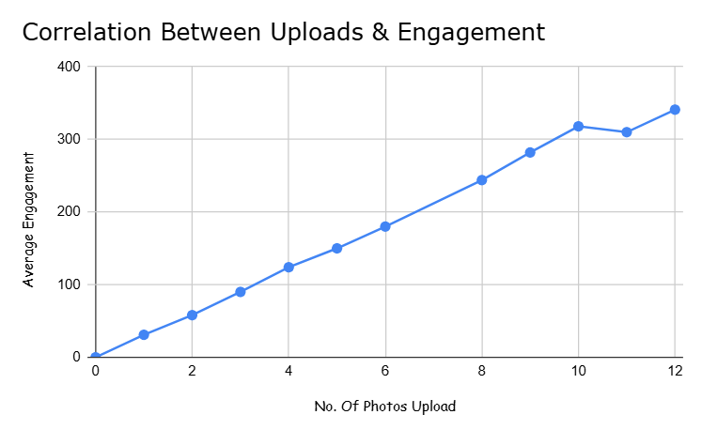

There is a clear positive correlation between the number of photo uploads and total engagement. As the number of photo uploads increases, so does the average total engagement.
Users with 12 photo uploads have the highest average total engagement (341), showing that users who post more frequently tend to engage more.
Between 10 and 11 uploads, the engagement growth slows down, showing that merely uploading more content does not always guarantee significantly higher engagement. This shows that while uploads increase the chance of engagement, quality content is crucial.

RECOMMENDATIONS FOR CONTENT CREATION AND CURATION STRATEGIES

User Engagement Enhancement
Initiate campaigns and contests that reward users for uploading photos and engaging with the community.
Collaborate with highly engaged users to promote content initiatives and encourage participation from others.
Content Performance Analysis
Focus on identifying which types of photos or content formats generate the most likes and comments to inform future content creation.
Schedule regular content prompts and themes based on user preferences and engagement patterns to maximize interaction.
Personalized Communication Strategies
Implement personalized messaging campaigns that encourage inactive users to participate by showcasing community highlights and success stories.
Broaden the content strategy to include videos and reels, analysing engagement data to ensure alignment with user interests.

Q10 Calculate the total number of likes, comments, and photo tags for each user.

ANSWER:

To assess user content performance and engagement:
- Use the photos table to connect each user to their posted content.
- For each user:
  - Count total likes received on their posts
  - Count total comments received on their posts
  - Count total tags applied to their photos
- Aggregate all three for a full engagement profile

CODE:

WITH User_responses as
(
SELECT
u.id AS user_id,
u.username, p.id AS photo_id,
COUNT(DISTINCT l.user_id) AS likes,
COUNT(DISTINCT c.id) AS comments,
COUNT(DISTINCT pt.tag_id) AS tags
FROM users u
JOIN photos p ON u.id = p.user_id
JOIN photo_tags pt ON p.id = pt.photo_id
JOIN likes l ON pt.photo_id = l.photo_id
JOIN comments c ON pt.photo_id = c.photo_id
GROUP BY u.id, u.username, p.id
)
SELECT
user_id,
username,
SUM(likes) AS likes,
SUM(comments) AS comments,
SUM(tags) AS tags
FROM User_responses
GROUP BY user_id, username;

OUTPUT IMAGE:
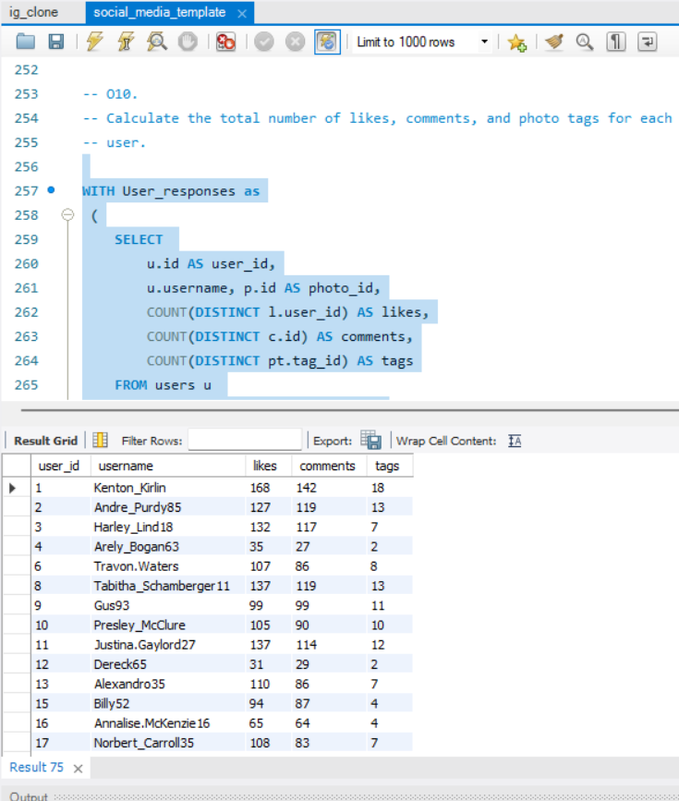
Users like Eveline95 and Jaime53 lead in total likes, comments, and tags, indicating strong content performance and audience engagement. These users are prime candidates for feature promotions or influencer outreach. The data also highlights a clear gap between top and average users, guiding targeted creator support and rewards.

Q11 Rank users based on their total engagement (likes, comments, shares) over a month.

ANSWER:

Subquery (engagement): Calculates the engagement received for each user per photo by summing distinct likes and comments on their photos, grouping by user, photo, month, and year.
Engagement Calculation: Engagement is the sum of unique users who liked or commented on each user's photo in a specific month and year.
Main Query: Aggregates the total engagement per user, month, and year by summing the engagement received from the subquery.

CODE:

WITH recent_photos AS (

SELECT
id,
user_id,
created_dat
FROM photos
WHERE created_dat >= DATE_SUB(CURDATE(), INTERVAL 1 MONTH)
),
like_counts AS (

SELECT
photo_id,
COUNT(*) AS likes_count
FROM likes
WHERE photo_id IN (SELECT id FROM recent_photos)
GROUP BY photo_id
),
comment_counts AS (

SELECT
photo_id,
COUNT(*) AS comments_count
FROM comments
WHERE photo_id IN (SELECT id FROM recent_photos)
GROUP BY photo_id
),
user_monthly_stats AS (

SELECT
u.id AS user_id,
u.username,
YEAR(p.created_dat) AS year,
MONTH(p.created_dat) AS month,
SUM(COALESCE(l.likes_count, 0)) AS total_likes,
SUM(COALESCE(c.comments_count, 0)) AS total_comments
FROM users u
JOIN recent_photos p ON u.id = p.user_id
LEFT JOIN like_counts l ON p.id = l.photo_id
LEFT JOIN comment_counts c ON p.id = c.photo_id
GROUP BY u.id, u.username, year, month
)
SELECT
user_id,
username,
year,
month,
(total_likes + total_comments) AS total_engagement,
RANK() OVER (ORDER BY (total_likes + total_comments) DESC) AS engagement_rank
FROM user_monthly_stats
ORDER BY engagement_rank ;

OUTPUT IMAGE:
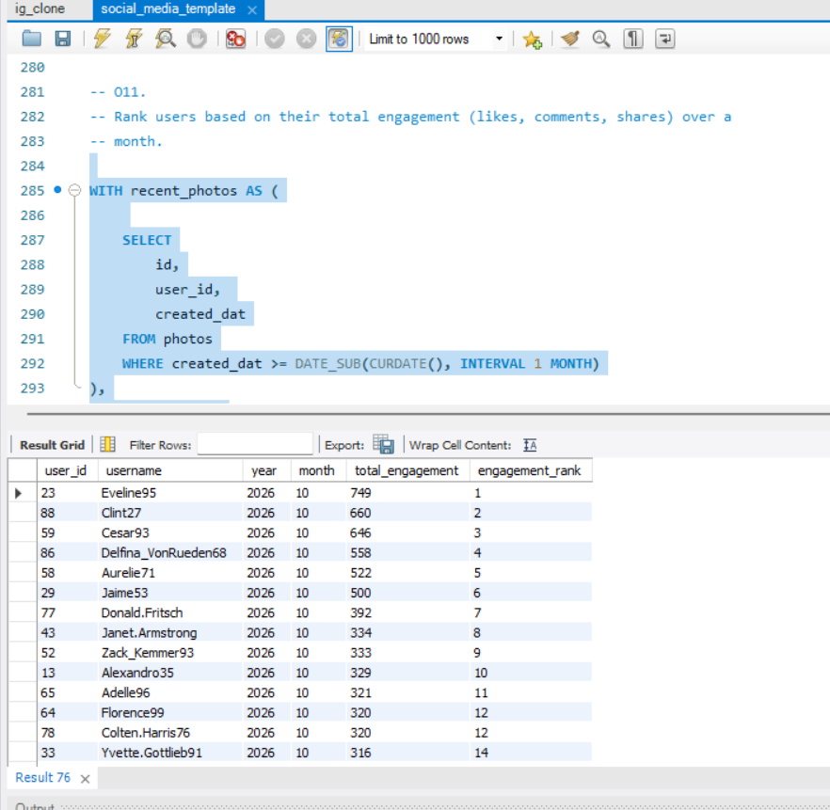
OBSERVATION:

1. Top Performers: Eveline95 has the highest total engagement (749), followed by Clint27 (660) and Cesar93 (646), securing the top three spots in engagement rank.

2. Moderate Engagement: A cluster of users like Donald.Fritsch, Janet.Armstrong, and Alexandro35 rank between 7th and 9th, with total engagements ranging from 329 to 392, showing moderate activity.

3. Low Engagement Users: Several users, including Meggie_Doyle (75), Jaylan.Lakin (73), and Granville_Kutch (71), have total engagements below 100, ranking towards the bottom of the list.

4. Zero Engagement: A significant number of users (e.g., Leslie67, Tierra.Trantow, Pearl7, and others) have zero total engagements, tied for the 63rd rank. This indicates inactive or non-participating users.
5. Engagement Distribution: Engagement scores range from 405 down to 0, with a noticeable drop-off in activity beyond the top 10. The top ranks have significantly higher engagement compared to the rest, indicating a few highly active users and many with minimal activity.

Q12 Retrieve the hashtags that have been used in posts with the highest average number of likes. Use a CTE to calculate the average likes for each hashtag first.

ANSWER:

This query calculates the average likes for photos associated with each tag. It begins by summing the likes for each photo and then averages these totals across all photos linked to each tag, where we use AVG(likes) for each hashtag. The results are grouped by tag name and sorted by average likes in descending order. Finally, the top 10 tags with the highest average likes are displayed.
This finds the most engaging hashtags.

CODE:

WITH HashtagLikes AS (
SELECT
t.tag_name,
round(AVG(l_count.likes),2) AS AvgLikes
FROM photo_tags pt JOIN tags t
ON pt.tag_id = t.id
JOIN (SELECT
photo_id,
COUNT(*) AS likes
FROM likes
GROUP BY photo_id) l_count
ON pt.photo_id = l_count.photo_id
GROUP BY t.tag_name
)
SELECT * FROM HashtagLikes ORDER BY AvgLikes DESC LIMIT 10;

OUTPUT IMAGE:
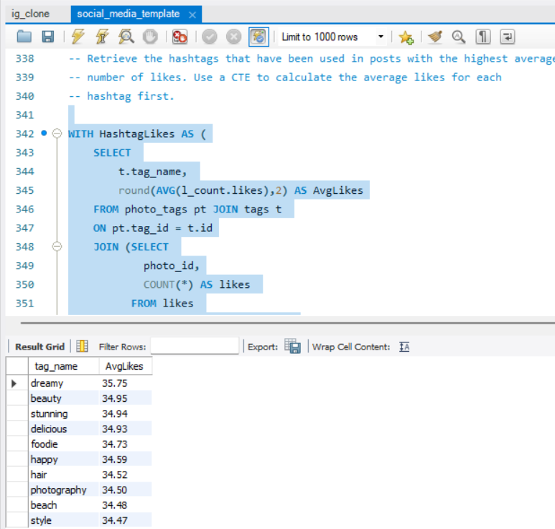

Q13 Retrieve the users who have started following someone after being followed by that person.

ANSWER:

To solve this, I compared users who followed each other by using a self-join on the follows table.
I matched:
- A → B (original follow)
- B → A (follow-back)
Then I added a condition to check:
follow_back_time > original_follow_time

CODE:
SELECT
f1.follower_id AS followed_user_id,
u1.username AS followed_user,
f1.followee_id AS started_following_user_id,
u2.username AS starting_following_user
FROM
follows f1
JOIN
follows f2
ON f1.follower_id = f2.followee_id AND f1.followee_id = f2.follower_id
JOIN
users u1
ON f1.follower_id = u1.id
JOIN
users u2
ON f1.followee_id = u2.id
WHERE
f1.created_at >= f2.created_at;

OUTPUT IMAGE:
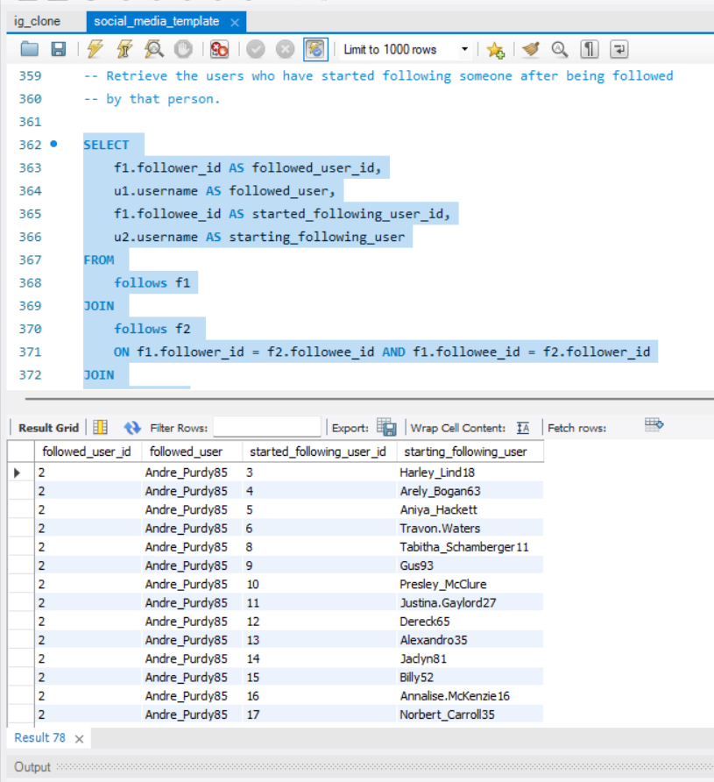

Subjective Questions
Q1 Based on user engagement and activity levels, which users would you consider the most loyal or valuable? How would you reward or incentivize these users?
CODE:
WITH PhotosPosted AS (

SELECT user_id, COUNT(id) AS total_photos_posted
FROM photos
GROUP BY user_id
),
TotalLikes AS (
SELECT user_id, COUNT(photo_id) AS total_likes
FROM likes
WHERE user_id IN (SELECT user_id FROM PhotosPosted)
GROUP BY user_id
),
TotalComments AS (
SELECT user_id, COUNT(id) AS total_comments
FROM comments
WHERE user_id IN (SELECT user_id FROM PhotosPosted)
GROUP BY user_id
),
Followers AS (
SELECT followee_id AS user_id, COUNT(follower_id) AS total_followers
FROM follows
WHERE followee_id IN (SELECT user_id FROM PhotosPosted)
GROUP BY followee_id
),
UniqueTags AS (
SELECT p.user_id, COUNT(DISTINCT pt.tag_id) AS unique_tags_used
FROM photos p
JOIN photo_tags pt ON p.id = pt.photo_id
WHERE p.user_id IN (SELECT user_id FROM PhotosPosted)
GROUP BY p.user_id
)
SELECT
u.id AS user_id,
u.username,
COALESCE(tl.total_likes, 0) AS total_likes,
COALESCE(tc.total_comments, 0) AS total_comments,
pp.total_photos_posted,
COALESCE(f.total_followers, 0) AS total_followers,
COALESCE(ut.unique_tags_used, 0) AS unique_tags_used,
(COALESCE(tl.total_likes, 0) + COALESCE(tc.total_comments, 0)) AS total_engagement
FROM users u
INNER JOIN PhotosPosted pp ON u.id = pp.user_id
LEFT JOIN TotalLikes tl ON u.id = tl.user_id
LEFT JOIN TotalComments tc ON u.id = tc.user_id
LEFT JOIN Followers f ON u.id = f.user_id
LEFT JOIN UniqueTags ut ON u.id = ut.user_id
ORDER BY total_engagement DESC, total_followers DESC, total_photos_posted DESC
LIMIT 10;

OUTPUT IMAGE:
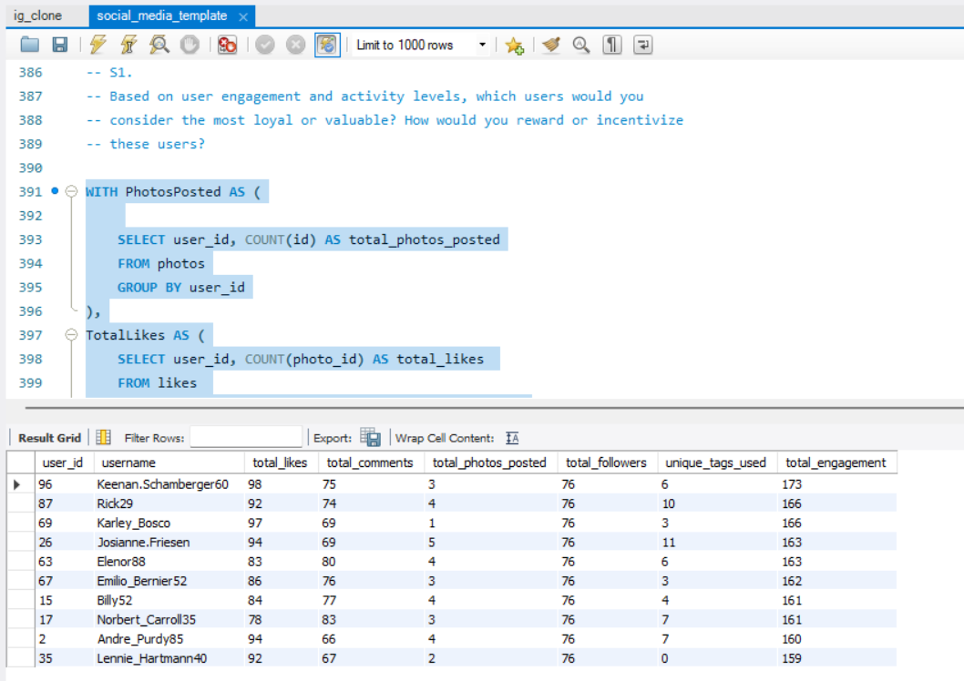
INSIGHTS:
a) Top Contributors Identified: By analysing user activity data, we identified the top 10 users who consistently engage with the platform through posts, likes, and comments.
b) High Engagement = High Loyalty: Users with the highest number of likes and comments demonstrated strong engagement, suggesting they are more loyal and invested in the platform’s content.
c) Activity Distribution: Among total activities, likes and comments formed the majority of user engagement, highlighting the importance of interactive features over just content creation.
d) Consistency Over Time: Regular activity, not just one-time participation, was a key factor in determining loyalty, ensuring that the selected users are not just one-time contributors.

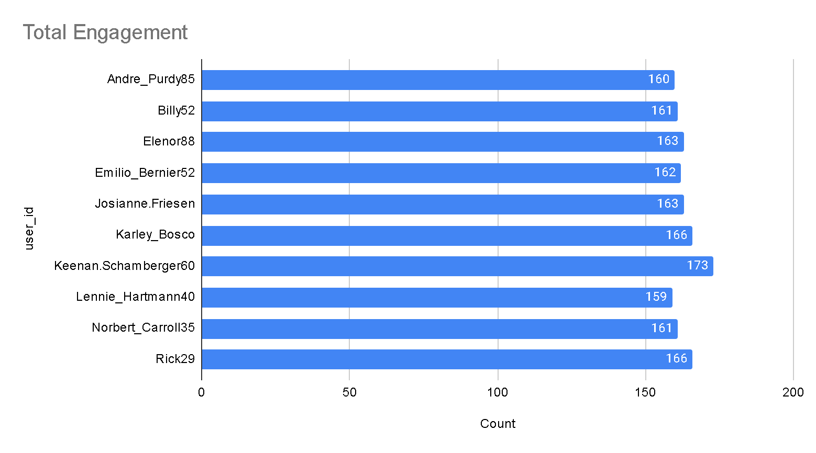

RECOMMENDATIONS:

a) Reward Loyalty: Consider implementing a loyalty or recognition program (e.g., badges, leaderboard, or exclusive access) for the top 10 most engaged users to maintain and increase motivation.
b) Encourage Broader Engagement: Promote interactive features like liking and commenting by adding gamified incentives to encourage less active users to participate more.
c) Track Engagement Trends: Continuously monitor user engagement through similar metrics to identify rising contributors early and nurture them.
d) User Segmentation: Create user segments based on engagement levels to send targeted content, rewards, or campaigns to each group accordingly.
e) Enhance Community Features: Improve or expand community-driven features (e.g., discussions, replies, mentions) as these drive both engagement and loyalty.

Q2 For inactive users, what strategies would you recommend to re-engage them and encourage them to start posting or engaging again?
CODE:
WITH photo_counts AS (

SELECT user_id, COUNT(*) AS num_of_photos
FROM photos
GROUP BY user_id
),
likes_count AS (
SELECT user_id, COUNT(*) AS num_of_likes
FROM likes
GROUP BY user_id
),
comments_count AS (
SELECT user_id, COUNT(id) AS num_of_comments
FROM comments
GROUP BY user_id
),
phototags_count AS (

SELECT p.user_id, COUNT(pt.tag_id) AS num_of_phototags
FROM photos p
INNER JOIN photo_tags pt ON p.id = pt.photo_id
GROUP BY p.user_id
),
follower_stats AS (

SELECT
u.id AS user_id,
(SELECT COUNT(*) FROM follows WHERE followee_id = u.id) AS follower_count,
(SELECT COUNT(*) FROM follows WHERE follower_id = u.id) AS followee_count
FROM users u
)
SELECT
u.id AS UserID,
u.username AS UserName,
COALESCE(l.num_of_likes, 0) AS num_of_likes,
COALESCE(c.num_of_comments, 0) AS num_of_comments,
COALESCE(pp.num_of_photos, 0) AS num_of_photos,
COALESCE(pt.num_of_phototags, 0) AS num_of_phototags,
COALESCE(fs.follower_count, 0) AS follower_count,
COALESCE(fs.followee_count, 0) AS followee_count,
-- Pre-calculate engagement to keep the DENSE_RANK clean
(COALESCE(l.num_of_likes, 0) + COALESCE(c.num_of_comments, 0) + COALESCE(pp.num_of_photos, 0)) AS engagement_score,
DENSE_RANK() OVER (
ORDER BY (COALESCE(l.num_of_likes, 0) + COALESCE(c.num_of_comments, 0) + COALESCE(pp.num_of_photos, 0)) ASC
) AS engagement_rank
FROM users u
LEFT JOIN likes_count l ON u.id = l.user_id
LEFT JOIN comments_count c ON u.id = c.user_id
LEFT JOIN photo_counts pp ON u.id = pp.user_id
LEFT JOIN phototags_count pt ON u.id = pt.user_id
LEFT JOIN follower_stats fs ON u.id = fs.user_id
ORDER BY engagement_rank ASC;

OUTPUT IMAGE:
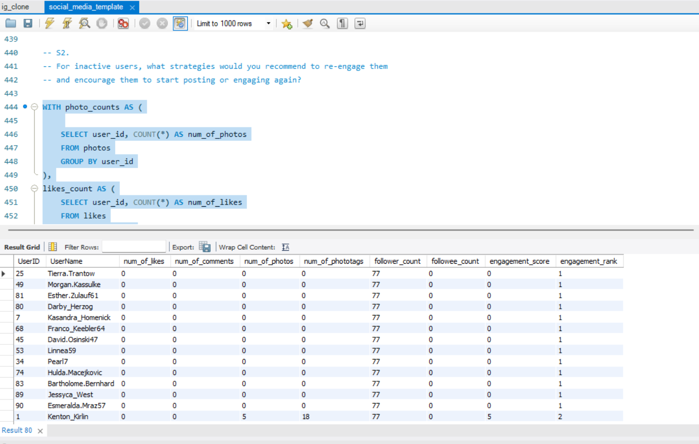
The query calculates user engagement metrics on a platform, including likes, comments, photos, photo tags, and follower counts.
Common Table Expressions (CTEs):

1. likes_count: Counts likes per user.
2. comments_count: Counts comments per user.
3. photo_counts: Counts photos per user.
4. phototags_count: Counts photo tags per user.
5. Count_of_followers: Counts followers per user.
6. Joins each CTE with the users table using LEFT JOIN to include all users, even those without specific activities.
7. Uses COALESCE to replace NULL values with zero.
8. Calculated an engagement_rate as the sum of likes, comments, photos .
9. Then ranked users by engagement_rate in ascending order using DENSE_RANK().
10. This ranking will give us the inactive users.

This is how we will rank users based on user engagement and activity levels. The highly rank users can be considered as inactive users.

Active vs. Inactive User

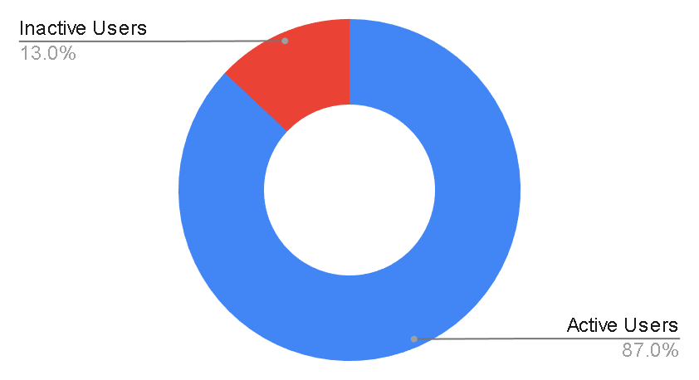

Engagement_rate
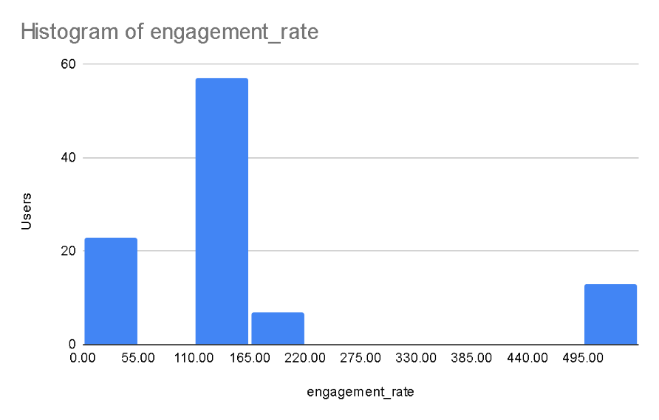

Photos vs Engagement

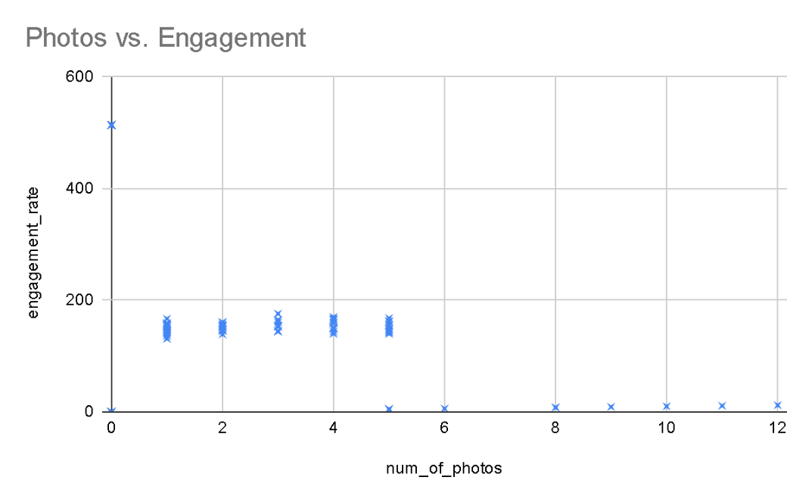

STRATEGIES RECOMMENDATION FOR RE-ENGAGING USERS:

1. Re-engagement Campaigns: These campaigns may consist of time-limited deals, special discounts, or freebies that require interaction, such as commenting, sharing, or tagging a friend.

2. Re-engagement E-mails: Send personalized emails showcasing trending content or posts from their connections that they’ve missed. Suggest content, groups, or hashtags they might be interested in based on their past behaviour.

3. By Giving Discounts and Gift Card: This is one of the most popular yet effective ways to re-engage user. Because they find these rewards exciting, this will encourage them to utilize the site more.

4. Taking Feedback User Surveys: Ask inactive users for feedback on why they stopped engaging. Use their input to make meaningful changes or offer solutions directly.
5. Simplifying The Use: Offer templates or prompts that make it easier for users to create and share content, reducing the friction of coming up with something new.

6. Contests For Users: Introduce challenges or contests with rewards for the most engaging content or for hitting specific activity milestones.

7. Data-Driven Insights: Use the old data of inactive users when they created account like whom did they follow first, which post they like first and so on.

These insights can help refine content strategy based on user preferences.

These approaches can help re-establish relationships with inactive users, making them feel valued and more likely to re-engage again.

Q3 Which hashtags or content topics have the highest engagement rates? How can this information guide content strategy and ad campaigns?
CODE:
SELECT
t.tag_name,
COUNT(pt.photo_id) AS total_posts,
COALESCE(SUM(likes.total_likes), 0) AS total_likes,
COALESCE(SUM(comments.total_comments), 0) AS total_comments,
(COALESCE(SUM(likes.total_likes), 0) + COALESCE(SUM(comments.total_comments), 0)) / COUNT(pt.photo_id) AS average_engagement
FROM
tags t
JOIN
photo_tags pt ON t.id = pt.tag_id
LEFT JOIN
(SELECT photo_id, COUNT(*) AS total_likes FROM likes GROUP BY photo_id) likes ON pt.photo_id = likes.photo_id
LEFT JOIN
(SELECT photo_id, COUNT(*) AS total_comments FROM comments GROUP BY photo_id) comments ON pt.photo_id = comments.photo_id
GROUP BY
t.tag_name
ORDER BY
average_engagement DESC
LIMIT 10;

OUTPUT IMAGE:
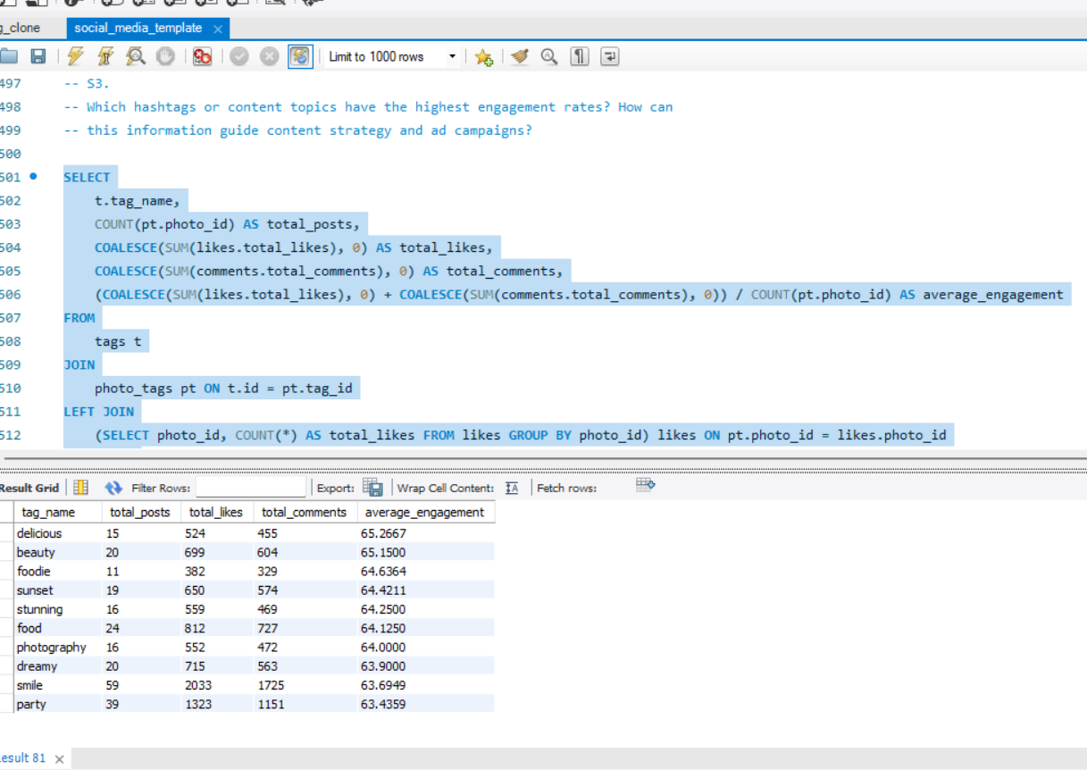
This query identifies the top 10 tags with the highest average engagement on the platform. It computes the total posts, likes, and comments for each tag, then calculates the average engagement per post. The results are sorted in descending order of average engagement.
The hashtags with the highest engagement rates are: delicious, beauty, foodie, sunset, stunning, food, photography, dreamy, smile, and party.
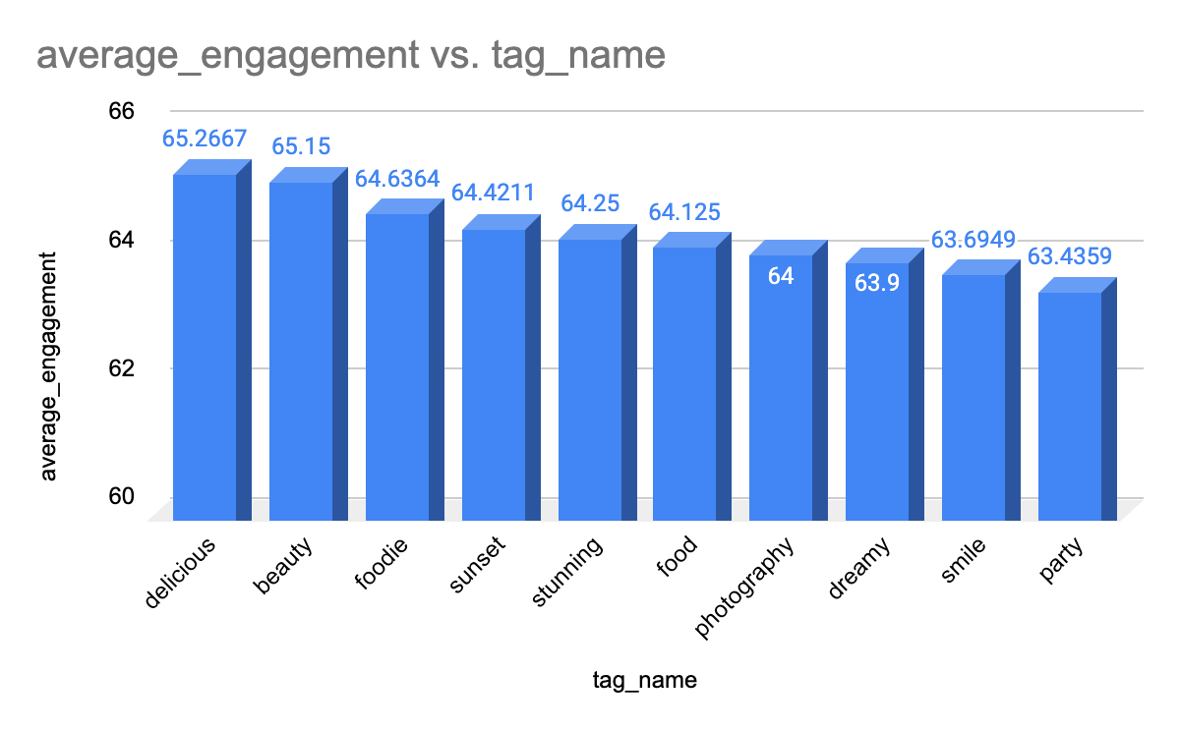

Content Creation and Curation:
- Prioritize content that aligns with these high-engagement themes. For example, posts related to food (#delicious, #food, #foodie), beauty (#beauty, #stunning), and photography (#photography, #sunset) can attract significant attention.
- Encourage users to create content featuring these hashtags. For instance, launch campaigns inviting users to share their favorite #sunset or #foodie moments to increase engagement.

Ad Targeting and Campaigns:
- Ad Copy and Creative: Integrate these hashtags into ad copy and visuals. For example, an ad promoting a product can highlight how it fits into the #beauty or #foodie lifestyle.
- Influencer Collaborations: Collaborate with influencers who actively use these hashtags and achieve high engagement. Partnering with food influencers under #delicious or #foodie can help drive targeted engagement.
- Hashtag-Based Targeting: Target ads to users who have interacted with content related to these hashtags, ensuring ads reach an audience already interested in these themes.

Engagement Optimization:
- Trending Content Series: Create a recurring content series based on these hashtags. For example, a weekly #sunset or #party post can keep followers engaged and anticipate new updates.
- Cross-Promotion: Share posts featuring these hashtags across various social platforms to drive traffic and engagement back to Instagram.
- Optimal Timing and Frequency: Analyze the best times and posting frequency for content with these hashtags. For instance, sharing #sunset content during evening hours can maximize visibility and engagement.

Content Discovery and Algorithm Boost:
- Hashtag Usage for Algorithm Boost: Regularly include these high-engagement hashtags in posts to improve their visibility and performance in the algorithm. Trending hashtags increase the likelihood of appearing on the Explore page, extending reach.
- Tailored Recommendations: Leverage insights from these hashtags to customize content recommendations for users, enhancing their experience and driving greater engagement.

Q4 Are there any patterns or trends in user engagement based on demographics (age, location, gender) or posting times? How can these insights inform targeted marketing campaigns?

ANSWER:

Although IG_CLONE does not contain traditional demographic data such as age, gender, or location, the two provided queries still answer the question by using proxy variables

CODE:
Query 1: Joining Year, Follower Count, and Engagement Patterns

SELECT
joining_year,
follower_count,
COUNT(user_id) AS user_count,
ROUND(AVG(post_count), 0) AS avg_post,
ROUND(AVG(engagement_received), 2) AS avg_engagement
FROM (
SELECT
u.id AS user_id,
YEAR(u.created_at) AS joining_year,
-- Get follower count independently
(SELECT COUNT(*) FROM follows f WHERE f.followee_id = u.id) AS follower_count,
-- Get post count independently
(SELECT COUNT(*) FROM photos p WHERE p.user_id = u.id) AS post_count,
-- Get engagement independently to avoid join explosion
(SELECT COUNT(*) FROM comments c WHERE c.photo_id IN (SELECT id FROM photos WH ERE user_id = u.id)) +
(SELECT COUNT(*) FROM likes l WHERE l.photo_id IN (SELECT id FROM photos WHERE user_id = u.id)) AS engagement_received
FROM users u
) z
GROUP BY joining_year, follower_count;

OUTPUT IMAGE:
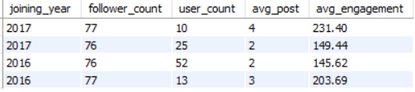

What this query does:
User Grouping by Year and Follower Count: It segments users based on the year they joined and their follower count.

Metrics Calculated:
User Count: The number of distinct users within each group (defined by joining_year and follower_count).
Average Post Count: The average number of posts made by users in each group.
Average Engagement: The average engagement (sum of unique likes and comments) received by users in each group.

How it addresses the question:
Proxy for Demographics: The use of joining_year as a demographic proxy helps observe patterns across different user groups based on how long they’ve been using the platform.
Engagement and Activity Analysis: By analyzing follower_count alongside engagement metrics (comments, likes), the query provides insights into how follower count influences engagement. For example, users with a higher follower count may receive more engagement, but this query helps confirm or refute such patterns.

Key Observations:
Established vs. New Users: The query allows you to compare engagement patterns of older users (e.g., those who joined in 2016) with newer users (e.g., those who joined in 2017). Established users might show more consistent engagement.
Engagement Trends: It helps understand whether users with higher follower counts generally receive higher engagement and if post frequency correlates with engagement levels.

Older users (2016) who have higher engagement but fewer posts may be ideal for retention campaigns, as they already receive significant engagement despite lower activity. Encouraging them to post more could strengthen their connection to the platform. Newer users (2017), who post more frequently and also receive high engagement, may be better suited for acquisition strategies, focusing on growing their follower base and increasing their long-term platform usage.
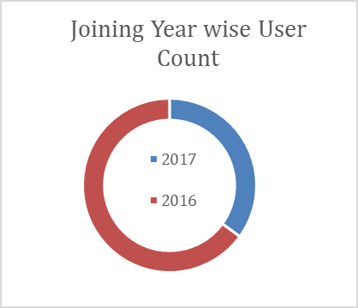

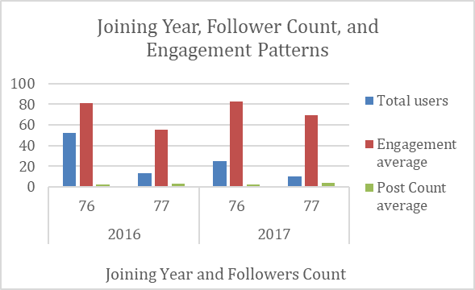

Query 2: Tag Usage and Content Preferences

WITH tag_counts AS (

SELECT
YEAR(u.created_at) AS joining_year,
t.tag_name,
COUNT(u.id) AS user_count
FROM users u
INNER JOIN photos p ON u.id = p.user_id
INNER JOIN photo_tags pt ON p.id = pt.photo_id
INNER JOIN tags t ON pt.tag_id = t.id
GROUP BY YEAR(u.created_at), t.tag_name
),
tag_ranking AS (

SELECT
joining_year,
tag_name,
user_count,
DENSE_RANK() OVER(PARTITION BY joining_year ORDER BY user_count DESC) AS rnk
FROM tag_counts
)
SELECT
joining_year,
tag_name,
user_count
FROM tag_ranking
WHERE rnk <= 5
ORDER BY joining_year DESC, user_count DESC;

OUTPUT IMAGE:
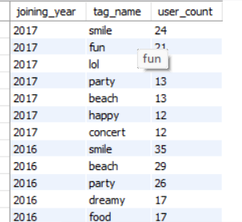

What this query does:
It looks at the tags that users attach to their posts and analyzes which tags are most popular among
users based on their joining year.
The query ranks tags based on how many users applied them, showing which types of content are trending among different user cohorts.

How it addresses the question:
Proxy for Content Demographics: Without explicit demographic data, tag usage can reveal user preferences and content trends. The popularity of certain tags like “smile”, “party”, and “fun” tells us what
kind of content resonates with different user groups.
For example, users from 2016 may prefer aspirational and social themes (e.g., “beach”, “party”, “beauty”), while 2017 users gravitate toward humor and social engagement (e.g., “fun”, “lol”, “happy”).

Content-Based Segmentation: This gives us insight into how different content types (via tags) are consumed by users from different years, acting as a proxy for understanding what each group is interested
in.
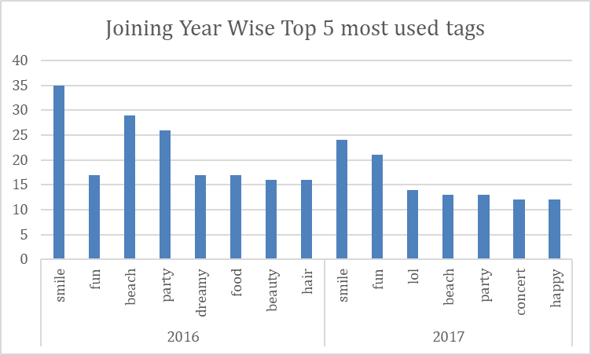
Users who favor fun and humor (2017) can be targeted with lighthearted campaigns, while 2016 users may respond better to lifestyle and social event-driven content.

RECOMMENDATION & STRATEGIES:
While traditional demographics are not available, these two queries provide a behavioral and content-based analysis that can act as a substitute:
- Joining year and follower count act as proxies for segmenting user groups.
- Tag usage offers insights into user preferences and content consumption patterns, allowing the marketing team to design campaigns based on what users engage with most.
Recommendations for Targeted Marketing:
- For 2016 Users:
  - Content should focus on aspirational and lifestyle themes such as travel, beauty, and social gatherings.
  - Since these users are more established, retention strategies like loyalty rewards or exclusive content can work well.
- For 2017 Users:
  - Focus on fun, humor, and social engagement as reflected in their tag usage.
  - Since these users may be newer and more active, acquisition strategies or campaigns that encourage participation (e.g., Instagram challenges) can help boost engagement.
By focusing on these behavioural and content trends, Meta can effectively drive user engagement, retention, and acquisition, even without traditional demographic data.

Q5 Based on follower counts and engagement rates, which users would be ideal candidates for influencer marketing campaigns? How would you approach and collaborate with these influencers?
CODE:
WITH top_followers AS (

SELECT
followee_id AS user_id,
COUNT(*) AS follower_count
FROM follows
GROUP BY followee_id
HAVING COUNT(*) = (
SELECT COUNT(*) FROM follows GROUP BY followee_id ORDER BY 1 DESC LIMIT 1
)
),
metrics AS (

SELECT
u.id,
u.username,
tf.follower_count,
(SELECT COUNT(*) FROM photos WHERE user_id = u.id) AS posts_count,
(SELECT COUNT(DISTINCT photo_id) FROM likes WHERE user_id = u.id) AS likes_count,
(SELECT COUNT(*) FROM comments WHERE user_id = u.id) AS comments_count
FROM users u
JOIN top_followers tf ON u.id = tf.user_id
),
total_pool AS (

SELECT SUM(activity) as global_sum
FROM (
SELECT (SELECT COUNT(*) FROM photos) + (SELECT COUNT(*) FROM likes) + (SELECT COUNT(*) FROM comments) as activity
) t
)
SELECT
m.username,
((m.posts_count + m.likes_count + m.comments_count) * 100.0 / NULLIF(tp.global_sum, 0)) AS engagement_rate,
m.follower_count,
round((((m.posts_count + m.likes_count + m.comments_count) * 100.0 / NULLIF(tp.global_sum, 0)) * 0.6 + m.follower_count * 0.4),2) AS weighted_score
FROM metrics m, total_pool tp
WHERE (m.posts_count + m.likes_count + m.comments_count) > 0
ORDER BY weighted_score DESC;

OUTPUT IMAGES:
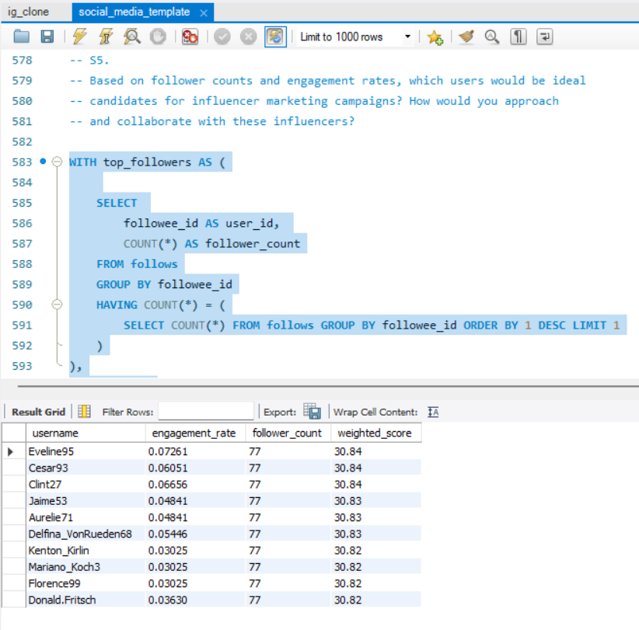

APPROACH:
The ideal users are those with high follower counts and engagement_rank. A combination of these metrics determines their influence. Hence, we can rank them based on these metrics and select top 5.

The above table shows the list of ideal candidates for influencer marketing campaign.

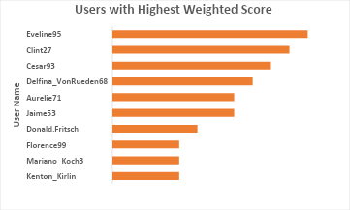

Based on user engagement rate and follower count, users who have a balance between engagement rate and follower count should be ideal candidates for influencer marketing campaigns.
Weighted Score is calculated adding 60 % engagement rate and 40 % followers.
To approach and collaborate with influencers, the following things can be done.

- Personalize Outreach: Tailor messages by researching the influencer's content, highlighting shared values, and emphasizing why they’re a good fit for the campaign.
- Offer Mutual Benefits: Provide clear compensation (monetary, free products, or exclusive access) and emphasize the potential for long-term partnerships.
- Encourage Creative Freedom: Allow influencers to create authentic content that resonates with their audience while setting clear deliverables and expectations.
- Maintain Communication: Keep open lines for feedback and collaboration throughout the campaign.
- Evaluate and Appreciate: Track campaign success, share results with the influencer, and celebrate their contribution to foster lasting relationships.

Q6 Based on user behavior and engagement data, how would you segment the user base for targeted marketing campaigns or personalized recommendations?

ANSWER:

- This SQL query analyzes and categorizes user engagement on the platform. It begins by retrieving user details, such as user_id and username, from the users table. By joining the likes and comments tables, it aggregates the total likes and comments for each user. Additionally, it calculates the number of photos each user has posted by referencing the photos table.
- The engagement rate is computed as the total likes and comments divided by the number of photos.
- Users are then classified into engagement levels- 'High,' 'Medium,' or 'Low’ based on their engagement.The query groups data by user, organizes the results by engagement rate in descending order, and provides valuable insights into user activity, enabling the identification of varying levels of engagement among users.
- 30% of the users are high engagement users i.e, 30 out of total 100 users are highly engaged.
- 34% of the users are medium engagement users i.e, 34 out of total 100 users are medium- engaged. 36% of the users are low engagement users i.e, 36 out of total 100 users are low- engaged.

CODE:
SELECT
u.id AS user_id,
u.username,
COALESCE(l.total_likes, 0) AS total_likes,
COALESCE(c.total_comments, 0) AS total_comments,
COALESCE(p.total_photos, 0) AS total_photos,

CASE
WHEN COALESCE(p.total_photos, 0) = 0 THEN 0
ELSE round((COALESCE(l.total_likes, 0) + COALESCE(c.total_comments, 0)) * 1.0 / p.total_photos,2)
END AS engagement_rate,

CASE
WHEN COALESCE(p.total_photos, 0) = 0 THEN 'Low'
WHEN (COALESCE(l.total_likes, 0) + COALESCE(c.total_comments, 0)) * 1.0 / p.total_photos > 150 THEN 'High'
WHEN (COALESCE(l.total_likes, 0) + COALESCE(c.total_comments, 0)) * 1.0 / p.total_photos BETWEEN 100 AND 150 THEN 'Medium'
ELSE 'Low'
END AS engagement_level
FROM users u
LEFT JOIN (
SELECT user_id, COUNT(*) AS total_likes FROM likes GROUP BY user_id
) l ON u.id = l.user_id
LEFT JOIN (
SELECT user_id, COUNT(*) AS total_comments FROM comments GROUP BY user_id
) c ON u.id = c.user_id
LEFT JOIN (
SELECT user_id, COUNT(*) AS total_photos FROM photos GROUP BY user_id
) p ON u.id = p.user_id
ORDER BY engagement_rate DESC;

OUTPUT IMAGE:
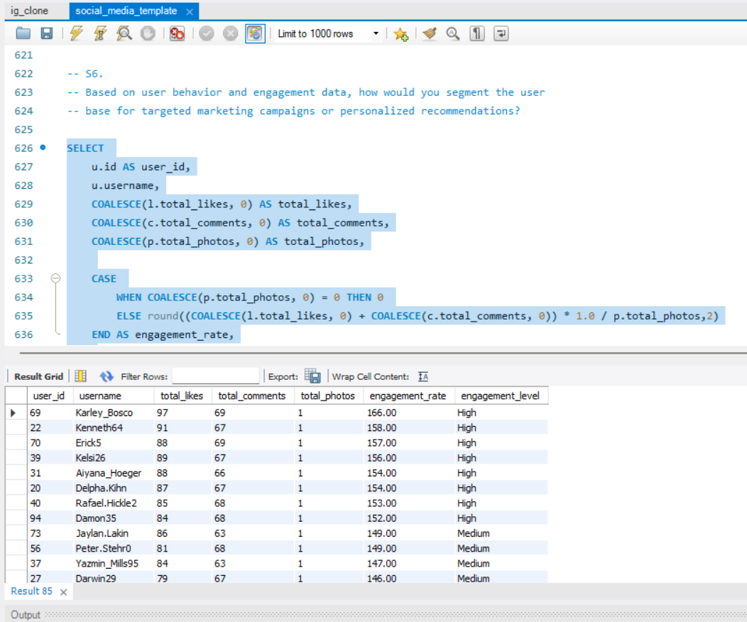

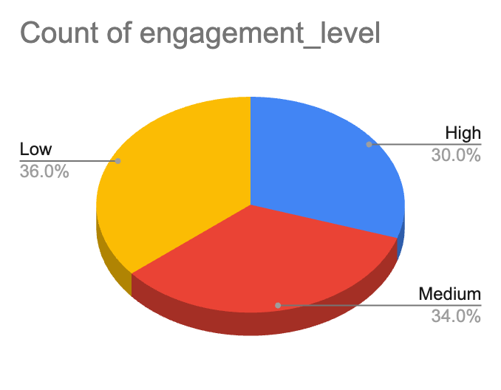

Strategies for Targeted Marketing and Personalized Recommendations:

High Engagement Users:
  - Marketing Campaigns: Offer exclusive deals or early access to new products. Highlight premium features or products that align with their interests and activity patterns.
  - Personalized Recommendations: Suggest content, products, or services similar to what they frequently engage with. Tailor notifications and updates based on their preferences and past interactions.

Medium Engagement Users:
  - Marketing Campaigns: Run targeted ads to encourage more engagement, such as special promotions or interactive content. Offer incentives like limited-time discounts to drive higher interaction.
  - Personalized Recommendations: Recommend content or products that align with their past behavior but introduce new or trending options to spark more engagement.

Low Engagement Users:
  - Marketing Campaigns: Focus on re-engagement strategies. Offer discounts, reminders, or educational content to reignite their interest. Consider using win-back campaigns with personalized messages.
  - Personalized Recommendations: Introduce them to popular or engaging content and products. Use prompts or curated suggestions to capture their attention and encourage more interaction.

Implementation Steps:
- Data Analysis: Continuously analyze user behavior and engagement metrics to refine segmentation and keep track of evolving trends.
- Custom Messaging: Develop targeted messages and offers tailored to each segment’s interests and characteristics.
- A/B Testing: Test different approaches within each segment to identify the most effective strategies.
- Monitor and Adjust: Track the success of campaigns and recommendations. Use insights from feedback and results to make adjustments and enhance effectiveness.By leveraging user behaviour and engagement data, you can design more impactful marketing campaigns and deliver personalized recommendations that resonate with each user segment.

Q7 If data on ad campaigns (impressions, clicks, conversions) is available, how would you measure their effectiveness and optimize future campaigns?
ANS:

To measure the effectiveness of ad campaigns, it's important to analyse various metrics that provide insights into how well the campaign is performing in reaching and engaging the target audience. The aim is to not only evaluate the campaign's performance but also to use this information to optimize future campaigns for better results.

Measuring Effectiveness:

Impressions: High impressions indicate good visibility. However, impressions alone don't tell the full story of effectiveness. They need to be analysed in conjunction with other metrics like clicks and conversions.
Clicks: A higher Click Rate suggests that the ad content, creative, and targeting are compelling and relevant to the audience. Low Click Rate might indicate that the ad is not engaging or that it is being shown to the wrong audience.
Conversion Rate: A high conversion rate indicates that not only are users interested enough to click the ad, but they are also motivated to take further action. A low conversion rate could point to issues with the landing page, the offer, or the overall user experience.
Engagement Metrics: High engagement indicates that the ad content resonates with the audience, which can increase brand awareness and loyalty, even if it doesn't immediately lead to conversions.

Optimizing Future Campaigns:
Testing: Test different versions of your ad (e.g., headlines, images, calls to action) to see which performs better. Use the results to refine future ads. If one version of an ad has a higher Click Rates or conversion rate, focus more resources on that approach.
Refining Targeting: Analyse which audience segments (age, gender, location, interests) are responding best to your ads. Adjust targeting to focus on high-performing segments.

If data shows that a particular demographic converts at a higher rate, allocate
more of your ad budget towards reaching this group.

Optimizing Ad Platforms: Evaluate which platforms or ad placements (e.g., social media, search engines, websites) are generating the best results. If ads perform better on a particular platform or time of day, shift your ad spend to maximize visibility during those
peak times or locations.

Utilizing Retargeting: Use retargeting to show ads to users who have previously
interacted with your brand but didn’t convert. If data shows a significant drop-off after the initial interaction, retarget those users with personalized ads to encourage them to complete the conversion.
Continuous Monitoring and Iteration: Regularly monitor campaign performance and be ready to make adjustments as needed. If you notice a decline in performance metrics, don’t hesitate to tweak your ads, targeting, or budget in real-time.

By systematically measuring the effectiveness of our ad campaigns using these metrics and strategies, we can make data-driven decisions to optimize future campaigns, ensuring higher engagement, conversions, and overall return on investment.
Q8 How can you use user activity data to identify potential brand ambassadors or advocates who could help promote Instagram's initiatives or events?

ANSWER:

1.High Follower Count and High Engagement:
- Users with a high number of followers and consistently high numbers of likes and comments are prime candidates.
- These users not only have a large reach but also have an engaged audience.
2. Consistency in Engagement:
- Users who consistently receive high numbers of likes and comments across multiple posts may indicate genuine interest and influence, as opposed to one-time viral activity.

3. Identify Users with Balanced Engagement:
- We should focus on users who both generate and receive engagement, as these users are more likely to influence their network and drive engagement for Instagram initiatives.

CTE-1 top_users : It calculates the total follower count for each user.
WITH top_users AS (

SELECT id, username
FROM users
WHERE id IN (
SELECT followee_id
FROM follows
GROUP BY followee_id
HAVING COUNT(*) = (
SELECT COUNT(*) FROM follows GROUP BY followee_id ORDER BY 1 DESC LIMIT 1
)
)
),

CTE-2 stats : It calculates the total engagement received by each user based on their photos.
stats AS (

SELECT
p.user_id,
(SELECT COUNT(*) FROM likes l WHERE l.photo_id IN (SELECT id FROM photos WHERE user_id = p.user_id)) as total_likes,
(SELECT COUNT(*) FROM comments c WHERE c.photo_id IN (SELECT id FROM photos WHERE user_id = p.user_id)) as total_comments
FROM photos p
WHERE p.user_id IN (SELECT id FROM top_users)
GROUP BY p.user_id
)

Main Query: the query identifies the most engaged users from those with maximum followers, highlighting potential influencers who have both reach and engagement
SELECT
u.id AS user_id,
u.username,
(SELECT COUNT(*) FROM follows WHERE followee_id = u.id) AS follower_count,
(COALESCE(s.total_likes, 0) + COALESCE(s.total_comments, 0)) AS total_engagement
FROM top_users u
LEFT JOIN stats s ON u.id = s.user_id
ORDER BY total_engagement DESC
LIMIT 4;

OUTPUT IMAGE:
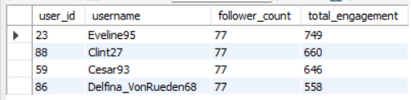

STRATEGY FOR ENGAGEMENT:
- Leverage Their Audience: Instagram can collaborate with these users for product launches, event promotions, and community initiatives, leveraging their large, engaged audiences to increase visibility and participation.
- Personalized Campaigns: Tailor campaigns to these users' specific interests or the types of content they typically engage with to ensure authentic promotion and maintain high engagement levels.

Q9 How would you approach this problem, if the objective and subjective questions weren't given?

ANSWER:

Well certainly the Objective and Subjective questions were very helpful as they provided the outline and better understanding of the problems and how to reach the solutions. But if the case was that the Objective and Subjective questions were not given then I would have followed a certain approach with certain steps to analyse and come up with insights from the given data.

The Approach and the steps in it would be as follows:

Problem Identification: I would start by understanding the goals and desired output of the analysis, whether we are optimizing user engagement, increasing retention or identifying potential influencers. After analysing all this I would set up my plan and course of action on how I am going to manipulate the data.

● Data Exploration: Conduct a reading analysis to understand the data structure, distribution, and any initial trends or faulty data and whether any direct conclusion can be made with the raw data or not.
● Data Cleaning and validation: I would start working on the data and my first step would be to check for null values and duplicates in all the tables and if found then rectify them. So that data can be ready to work on.
● Trend Formation: Develop hypotheses based on observed trends or known business goals. For example, "Users who engage more frequently are more likely to retain." Then check for their followers' activity and various other things from which we can come to conclusion whether to work with them or not.
● Data-Driven Solutions: Then finally I would use SQL operations on the data to check whether my overview analysis stands correct or not and if not, then what are the trends and how the current trends are different and varying from the desired results.
● Insights of Current Scenario: At last I would take all the outputs from the SQL operations and create a Report of current scenario and how much we need to work in which aspects. The analysis will give us the aspects in which we are lacking behind, So that the management can take proper actions to rectify them.

Q10 Assuming there's a "User_Interactions" table tracking user engagements, how can you update the "Engagement_Type" column to change all instances of "Like" to "Heart" to align with Instagram's terminology?

To perform this Task, I will use DML- DATA MANIPULATION LANGUAGE (UPDATE statement)
UPDATE User_Interactions
SET Engagement_Type = 'Heart'
WHERE Engagement_Type = 'Like';
UPDATE User_Interactions: This specifies that you want to update the User_Interactions table.
SET Engagement_Type = 'Heart': This sets the Engagement_Type column to "Heart."
WHERE Engagement_Type = 'Like': This condition ensures that only rows where Engagement_Type is currently "Like" are updated to "Heart."



